**Appendix-I**

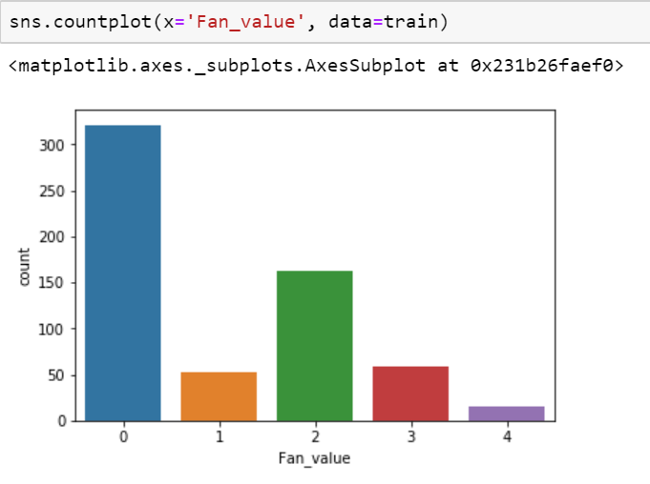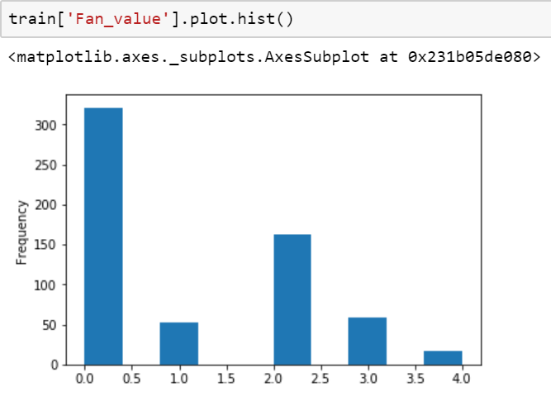**SNAPSHOTS**

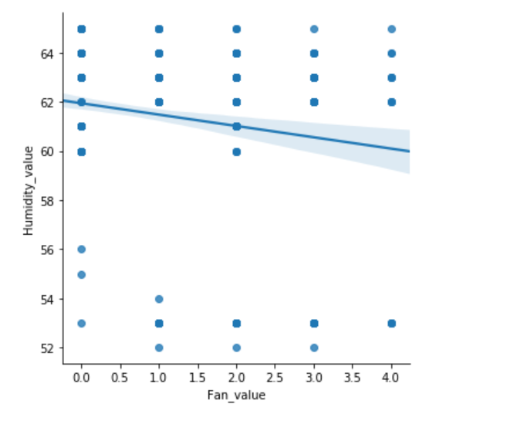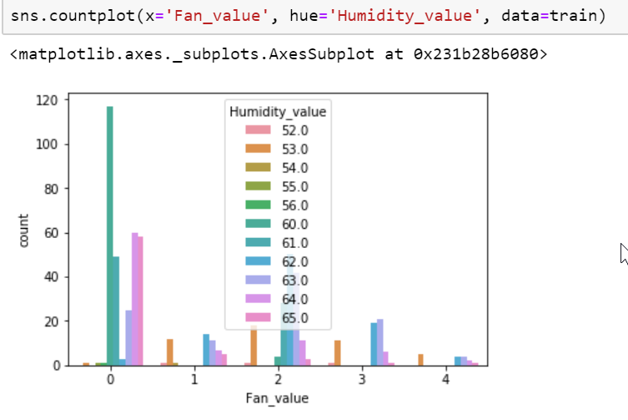

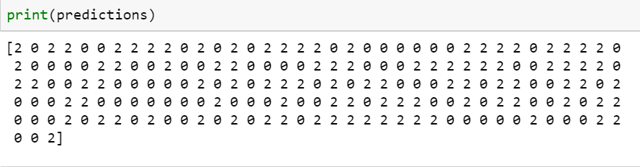

**Appendix - II**

**Source Code**

Humidity and Temperature File

#include "config.h"

#include "GoogleAssistant.h"

/************************ Code Starts Here *******************************/

#include <Adafruit_Sensor.h>

#include "DHT.h"

#include "SPI.h"

#define DHTTYPE DHT11

DHT dht(DHTPIN, DHTTYPE);

const int ldrPin = A0;

int lr, r;

// set up the 'temperature' and 'humidity' feeds

AdafruitIO_Feed *temperature = io.feed("Temperature"); //Send Temperature

AdafruitIO_Feed *humidity = io.feed("Humidity"); //Send Humidity

AdafruitIO_Feed *fs = io.feed("Fs"); //for controlling the speed of the fan

AdafruitIO_Feed *lights = io.feed("lights"); //ON or OFF the light

AdafruitIO_Feed *li = io.feed("li"); //Send LUX

void setup() {

Serial.begin(115200); // start the serial connection

while (! Serial); // wait for serial monitor to open

dht.begin(); // initialize dht22

Serial.print("Connecting to Adafruit IO");

io.connect(); // connect to io.adafruit.com

fs->onMessage(handleMessage);

lights->onMessage(lifhtscheck);

while (io.status() < AIO_CONNECTED) // wait for a connection {

Serial.print(".");

delay(500);

}

Serial.println();

Serial.println(io.statusText());

pinMode(ldrPin, INPUT);

pinMode(D2, OUTPUT);

pinMode(D3, OUTPUT);

pinMode(D4, OUTPUT);

pinMode(D5, OUTPUT);

pinMode(D6, OUTPUT);

}

void loop() {

io.run();

float c = dht.readTemperature();

Serial.print("celsius: ");

Serial.print(c);

Serial.println("C");

temperature->save(c);

float h = dht.readHumidity();

Serial.print("humidity: ");

Serial.print(h);

Serial.println("%");

humidity->save(h); // save humidity to Adafruit IO

Serial.print("Light Intensity:");

int in = analogRead(ldrPin) - 7;

Serial.print(in);

Serial.println(" Lux");

li->save(in);

if (r == 0)

{ digitalWrite(D2, HIGH);

digitalWrite(D3, HIGH);

digitalWrite(D4, HIGH);

digitalWrite(D5, HIGH);

Serial.println(r);

}

else if (r == 1)

{ digitalWrite(D2, LOW);

digitalWrite(D3, HIGH);

digitalWrite(D4, HIGH);

digitalWrite(D5, HIGH);

Serial.println(r);

}

else if (r == 2)

{ digitalWrite(D3, LOW);

digitalWrite(D2, HIGH);

digitalWrite(D4, HIGH);

digitalWrite(D5, HIGH);

Serial.println(r);

}

else if (r == 3)

{ digitalWrite(D4, LOW);

digitalWrite(D2, HIGH);

digitalWrite(D3, HIGH);

digitalWrite(D5, HIGH);

Serial.println(r);

}

else if (r == 4)

{ digitalWrite(D5, LOW);

digitalWrite(D2, HIGH);

digitalWrite(D4, HIGH);

digitalWrite(D3, HIGH);

Serial.println(r);

}

if (lr == 1)

{ digitalWrite(D6, LOW);

Serial.println("ON");

}

else if (lr == 0) {

digitalWrite(D6, HIGH);

Serial.println("OFF");

}

delay(5000); // wait 5 seconds (5000 milliseconds == 5 seconds)

}

void handleMessage( AdafruitIO_Data *data) {

r = data-> toInt();

}void lifhtscheck( AdafruitIO_Data *data)

{ lr = data-> toInt();

}

**Appendix-III**

**Datasheets**

